Task 12
Practice task
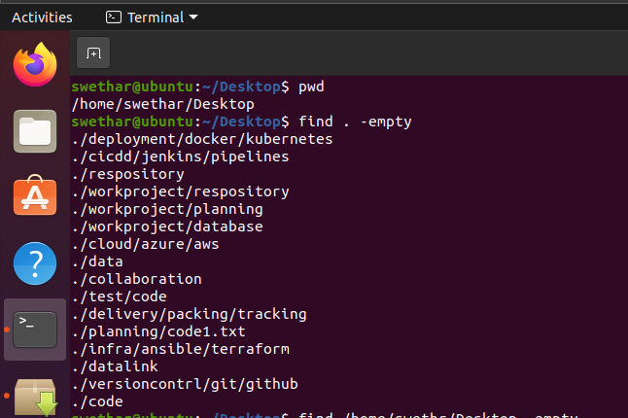
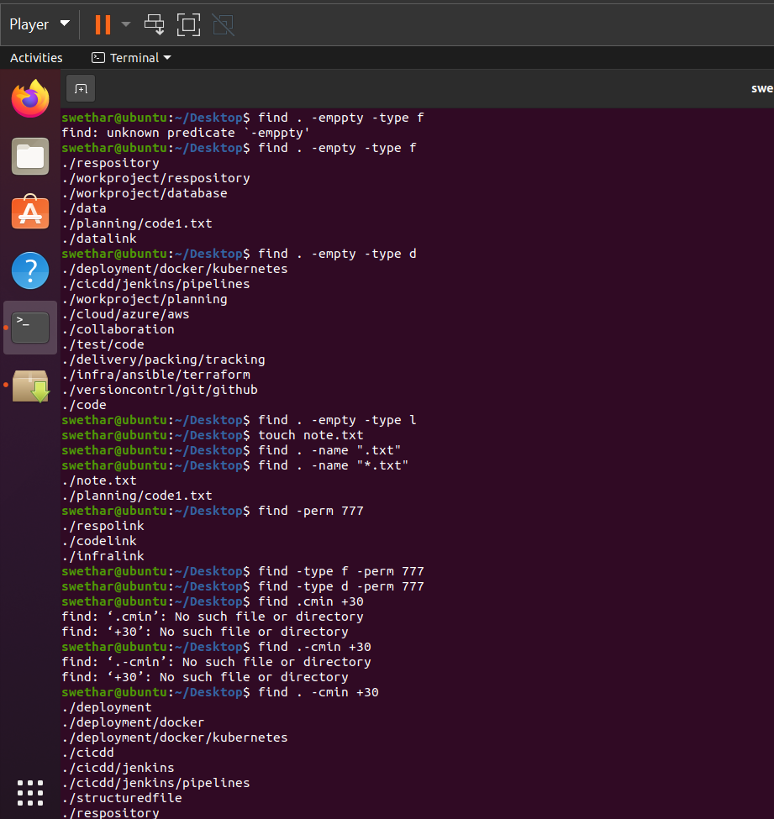
Additional task
1. Find all the files which are greater than 4kb and delete it
find . -type f -size +4k -delete
2. Find all the files with .txt and change the permission to 777
3. Find all the files in pwd, but search only up to a maximum depth of 2 levels.
hint find . -maxdepth 2 -type f

